Department of Computer Science & Engineering



Project Title: Library Management System
Course No: CSE 3210
Submitted To | Submitted By
Associate Professor Md. Mojahidul Islam  Dept. of Computer Science & Engineering Islamic University, Bangladesh. | Tanvir Ahmed  Roll No: 2114028  Reg. No: 1093  Session: 2021-22  Dept. of Computer Science & Engineering Islamic University, Bangladesh.

01/11/26

Declaration
We, hereby, declare that the work presented in this project is the outcome of the investigation performed by us under the supervision of Md. Mojahidul Islam, Associate Professor, Department of Computer Science & Engineering, Islamic University, Bangladesh. We also declare that the Library Management System has been developed with integrity and adherence to ethical standards. By signing below, we affirm our dedication to delivering a Library Management System that meets ethical standards and fulfills user expectations.

Signature
Tanvir Ahmed
Roll: 2114028
Session: 2021-22

Certification
I am pleased to certify that Tanvir Ahmed (Roll No: 2114028, Reg. No: 1093, Session: 2021-22) has successfully completed a project titled "Library Management System" under my supervision. This project fulfills the partial requirements for the degree of B.Sc.

Certified By

Md. Mojahidul Islam
Associate Professor
Dept. of Computer Science & Engineering
Islamic University, Bangladesh.

Acknowledgement
It is a great pleasure to convey my heartiest gratitude to Allah for the successful completion of the project work. The successful completion of any task requires the effort of many people and this work is not different. Firstly, I would like to express my sincere gratitude to my project supervisor Md. Mojahidul Islam, Associate Professor, Department of Computer Science & Engineering, Islamic University, Bangladesh.

I am also grateful to other teachers of the Department of Computer Science and Engineering, Islamic University, Bangladesh for their valuable suggestions and inspiration from time to time. I would like to express my deepest appreciation to the Department of Computer Science and Engineering for their cooperation during my studies and for giving me the opportunity to complete this project.
I will not forget my friends and relatives who supported me in every respect during the completion of this project.

Abstract
The Library Management System is a web-based application developed to provide an easy and convenient platform for managing library activities digitally. The main objective of this project is to create a system where users can search, issue, and return books efficiently without maintaining manual records.
This system allows users to view book details such as title, author, availability, and description. Members can search for books and borrow them through the system. The admin panel helps the administrator manage books, categories, member information, and book transactions efficiently.
The project is developed using basic web technologies such as HTML, CSS, JavaScript, and a backend database system. It reduces manual work, saves time, and provides a user-friendly interface for both users and administrators.

Table Of Contents

Chapter 1:Introduction
Chapter 2:System Analysis
Chapter 3:System Requirements
Chapter 4:System Design
Chapter 5:Implementation
Chapter 6:Discussion And Future Scopes

Chapter1:Introduction

1.1 Project Overview
The Library Management System is a web-based application developed to provide users with a simple platform to manage and access library resources online. The main purpose of this project is to make book searching, borrowing, and returning easy, fast, and accessible from anywhere using the internet.
The system allows users to view different books, check details such as author name, title, availability, category, and description, and borrow books as per library rules. Users can search for books and explore various categories according to their interests. The interface is designed to be simple, responsive, and user-friendly.
This project is developed using basic web technologies and a database to store book information and user records. It reduces manual work in libraries and helps in maintaining records efficiently. It also minimizes the need for paperwork and saves time for both users and administrators.
Overall, the Library Management System demonstrates a simple user-based system that focuses on efficient library management and easy access to books.

1.2 Objectives
The main objectives of the Library Management System project are:
- To develop a web-based platform that allows users to search, borrow, and return books easily.
- To provide detailed information about books, including title, author, availability, category, and description.
- To implement a search system so users can quickly find their desired books.
- To create a user-friendly and responsive interface for smooth navigation.
- To allow users to borrow books and manage their borrowed items efficiently.
- To store and manage book and user data using a database for efficient data handling and retrieval.
- To provide a digital alternative to traditional library systems, saving time and effort for users and administrators.

1.3 Scope of the System
The scope of the Library Management System is limited to user-side functionalities for managing and accessing books online. The system focuses on providing a simple and efficient platform where users can explore available books and borrow them through a web interface.
The system allows users to:
•View a list of available books.
- Check detailed information such as title, author, availability, category, and description.
- Search for books using keywords.
- Borrow books according to availability.
- Manage borrowed books and keep track of return status.
The system stores book and user information in a database and displays it dynamically on the website. It is accessible through any device with an internet connection and a web browser.

Chapter 2: System Analysis

2.1 Problem Statement
In traditional library systems, users often face difficulties such as limited access to book information, manual record-keeping, and time-consuming borrowing and returning processes. Finding a specific book can be difficult, and managing records manually can lead to errors and inefficiency.
There is a need for a system that allows users to search, borrow, and manage books easily from anywhere, without depending on manual processes. The lack of a simple and user-friendly digital platform for library management limits accessibility and efficiency for both users and administrators.
The Library Management System project addresses this problem by providing a web-based solution that allows users to view available books, check details like author and availability, search for specific books, and manage their borrowed books efficiently. This system aims to reduce manual effort, save time, and make library services faster, easier, and more accessible.
To address these challenges, this project proposes a web-based Library
Management System using the Databased is used to store book and user data, Express and Node.js handle the backend server and API requests, while React provides a responsive and interactive user interface.
This system aims to simplify library operations, improve accessibility, and provide a smooth and user-friendly experience. By digitizing library management, the project saves time for users and administrators and demonstrates how modern web technologies can be used to build a scalable and efficient system.

2.2 Requirement Analysis
The Library Management System is designed to provide a simple and efficient platform for users to search, borrow, and manage books online. This section outlines the functional and non-functional requirements essential for the system’s implementation.
2.2.1 Functional Requirements
These define the core functionalities that the system must provide for users:

User Management
Users must be able to register, log in, and manage their profiles.
Secure authentication should be implemented using JWT (JSON Web Tokens) with Node.js and Express.
Passwords and sensitive data must be encrypted in the database using MongoDB security practices.

Book Browsing and Details
Users should be able to view the list of all available books.
Each book must display details such as title, author, availability, category, and description.
Users should be able to search for books by title or author.

Borrowing Management
Users can borrow books based on availability.
Users can view and manage their borrowed books.
Users can return borrowed books within a specified time.

Record Management
The system keeps records of borrowed and returned books.
Users can view their borrowing history.
Notifications
Users receive visual confirmation after borrowing or returning books.

2.2.2 Non-Functional Requirements
These define the operational qualities of the system:

Performance Requirements
The system should handle multiple users searching and borrowing books simultaneously without performance degradation.
Search operations should return results quickly, within 2 seconds.

Security Requirements
User credentials and sensitive data must be encrypted.
Unauthorized users must not access user account details or library records.

Usability Requirements
The user interface must be responsive and intuitive.
The system should be accessible on different devices such as desktops, tablets, and mobile phones.

Maintainability and Scalability
The system should allow easy updates and addition of new features, such as advanced tracking or notification systems in the future.
The database should efficiently handle growing numbers of users and books.

Reliability and Availability
The system should ensure high uptime for user accessibility.
User and book data should be backed up regularly to prevent data loss.

Chapter 3: System Requirement

3.1 Introduction
The Library Management System is designed to provide a simple and efficient platform for managing library operations digitally. The system allows users to search, borrow, and return books easily without maintaining manual records. The system is developed using modern web technologies with a robust database to ensure fast data retrieval and reliable storage. The project follows a three-tier architecture, including the front-end, back-end, and database layers, allowing smooth interaction between users and the system.

HTML
Example:
<!DOCTYPE html>
<html>
<head>
<title>Page Title</title>
</head>
<body>
<h1>Library Management System</h1>
<p>Welcome to the library system.</p>
</body>
</html>
What is this?

CSS
CSS (Cascading Style Sheets) is used to style the HTML elements and create a visually appealing and responsive design. CSS allows the Library Management System to adapt to different screen sizes, including desktops, tablets, and mobile devices.
There are three ways of inserting a style sheet:
- External CSS
- Internal CSS
- Inline CSS

1. External CSS
The CSS is stored in a separate .css file and linked to the HTML document using the <link> tag inside the <head> section. This method is ideal for large projects and ensures consistent styling across multiple web pages.
Example:
CSS File (styles.css):
/* styles.css */ body {
background-color: #f4f4f4; font-family: Arial, sans-serif;
} h1 { color: #333; text-align: center;
} p {
font-size: 16px; color: #666; }
HTML File (index.html):
<!DOCTYPE html>
<html lang="en">
<head>
<meta charset="UTF-8">
<meta name="viewport" content="width=device-width, initial-scale=1.0">
<title>External CSS Example</title>
<link rel="stylesheet" href="styles.css"> <!-- Linking External CSS --> </head>
<body>
<h1>Welcome to Library Management System</h1>
<p>This is an example of an external CSS file.</p> </body>
</html>

2. Internal CSS
Internal CSS is placed within the <style> tag inside the <head> section of an HTML document.
It is useful for styling a single page without affecting other pages. Example:
<!DOCTYPE html> <html lang="en"> <head> <meta charset="UTF-8"> <meta name="viewport" content="width=device-width, initial scale=1.0"> 16 <title>Internal CSS Example</title> <style> body { background-color: #e6e6e6; font-family: Verdana, sans-serif; } h1 { color: darkblue; text-align: center; } p { } font-size: 18px; color: darkgray; </style> </head> <body> <h1>Internal CSS Example</h1> <p>This page is styled using internal CSS.</p> </body> </html>
3. Inline CSS
Inline CSS is applied directly to an HTML element using the style attribute. It is useful for quick styling but is not recommended for large projects. Example:
<!DOCTYPE html> <html lang="en"> <head> <meta charset="UTF-8"> <meta name="viewport" content="width=device-width, initial scale=1.0"> <title>Inline CSS Example</title> </head> <body> <h1 style="color: red; text-align: center;">Inline CSS Example</h1> <p style="font-size: 20px; color: blue;">This paragraph is styled using inline CSS.</p> </body> </html>
JavaScript
JavaScript is used to add interactivity and dynamic behavior to the website. It allows real-time
updates of content, handling of user actions like adding books to the cart, and smooth page
interactions without reloading the page
<!DOCTYPE html> <html> <body> <h2>JavaScript in Body</h2> <p id="demo"></p> <script> document.getElementById("demo").innerHTML = "My First JavaScript"; </script> </body> </html>

3.2.3Database
MongoDB MongoDB is a NoSQL database used to store book information, user data, and order details. Its document-oriented structure allows flexible and scalable storage of data, supporting the growth of books and users in the system.

3.4 Software Requirement
XAMPP
XAMPP is a free, open-source web server solution that provides Apache, MySQL/MariaDB, PHP, and Perl. It allows developers to create a local server environment for testing APIs, database connections, and web applications. Although the Online Book Shop project uses the MERN stack, XAMPP can be useful for managing databases locally and testing server-side components during development

Chapter: 4 System Design

4. System Design
The System Design section explains the architecture, modules, data flow, and interaction between components of the Library Management System. It helps readers understand how the system functions and how data moves from the user interface to the database.
4.1 System Architecture
Describe the three-tier architecture:•
- Frontend (React.js) – User interface for searching books, viewing details, borrowing books, and managing borrowed records.
- Backend (Node.js + Express.js) – Handles API requests, manages user authentication, borrowing/return operations, and communicates with the database.
- Database (MongoDB) – Stores user data, book information, and borrowing history.

  - Use Case Diagram
Showtheuser interactions: Register/Login, View Books, Search Books, Add to Cart,• Place Order, View Order History. Thisdiagram visualizes what the user can do in the system.
  - Data Flow Diagram (DFD)
Level0DFD(Context diagram): Show the user as an external entity, interacting with the system for browsing books and placing orders. Level1DFD:Break down the main processes like User Management, Book Browsing, Cart Management, and Order Placement. Thisexplains how data flows inside the system.

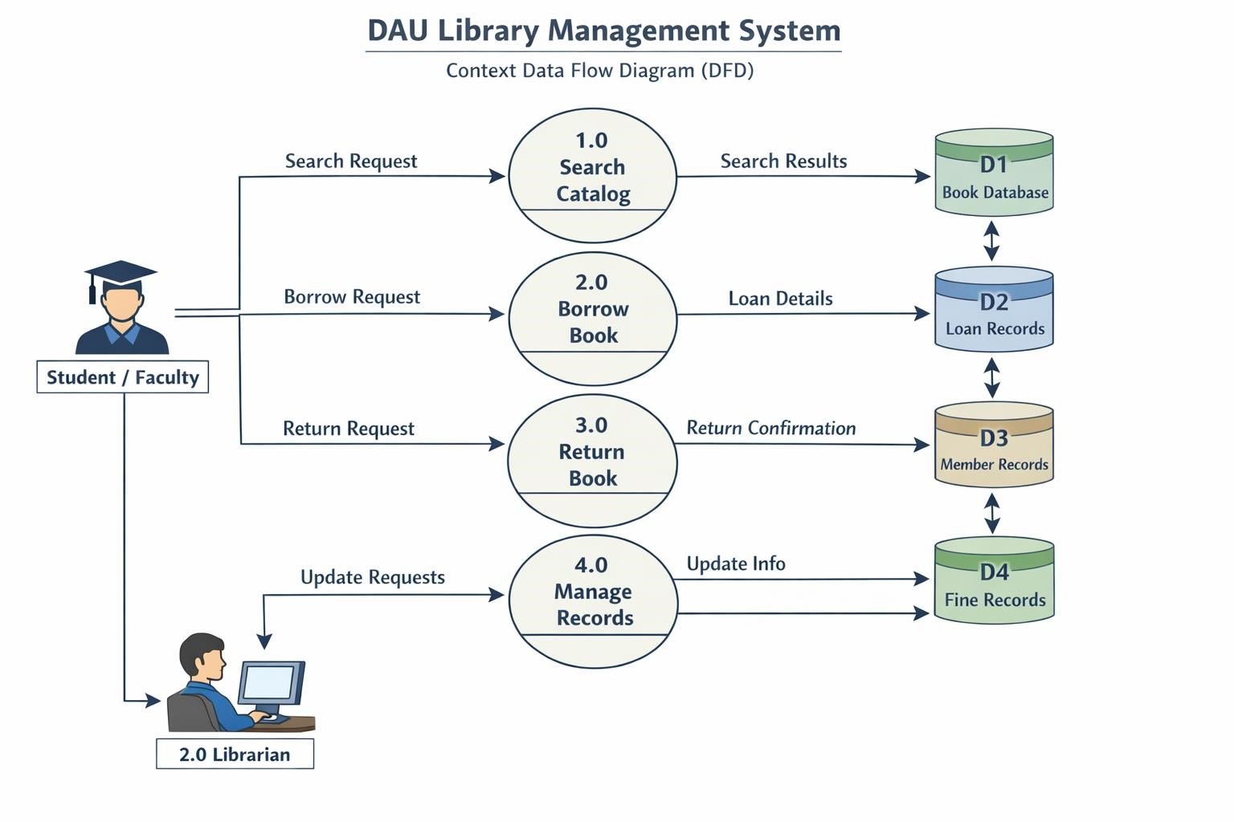

  - ER Diagram (Entity-Relationship Diagram) 22 Showcollections (tables) in MongoDB:
- Users o Books o Orders Showrelationships: User → Orders → Books (many-tomany via orders).
- This helps understand database structure and relationships.

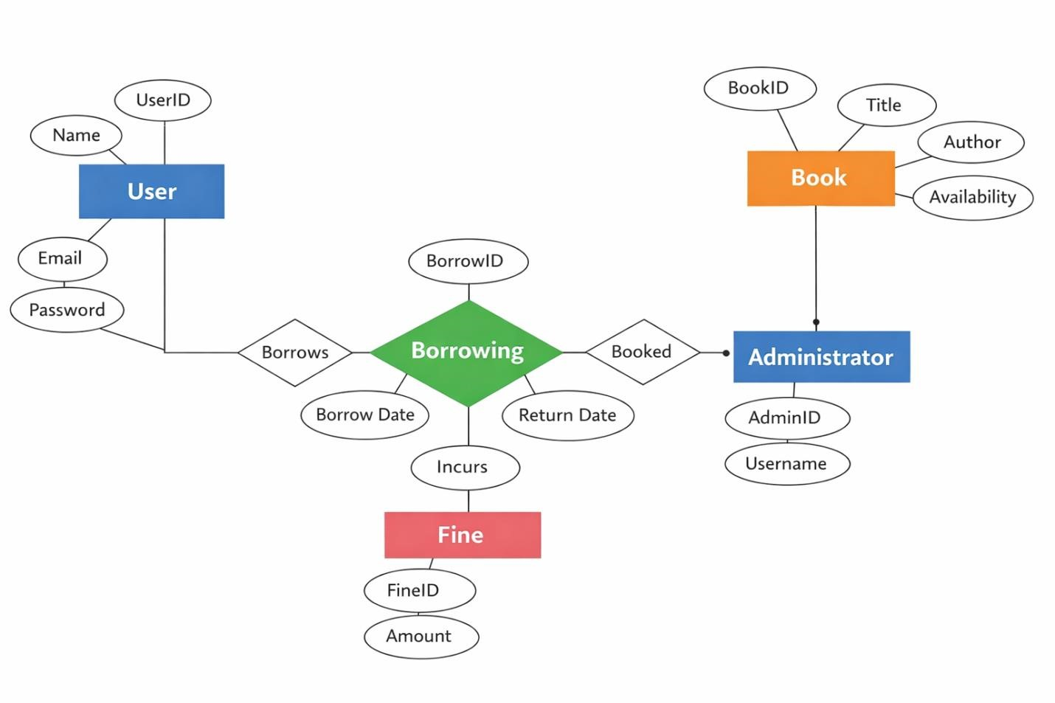
4.5 Module Description
- User Module – Handles user registration, login, and profile management.
- Book Module – Manages the display of books, provides search functionality, and shows detailed information about each book.
- Borrow/Return Module – Handles borrowing and returning of books, updates book availability, and manages due dates.
- Admin Module – Allows administrators to manage books, users, and system settings.
4.6 Sequence Diagram (Optional)
- Illustrates the order of operations, for example, when a user searches for a book, borrows it, and returns it.
- Helps explain backend/frontend interaction and API flow within the system.

Chapter 5: Implementation

5.1 Introduction

The Implementation chapter focuses on the practical realization of the Library Management System. This phase involves transforming the system design and architecture into a fully functional application. It covers the setup of the development environment, database creation, user interface development, and integration of frontend with backend services.
In this chapter, the steps taken to implement various modules such as User Module, Book Module, Borrow/Return Module, and Admin Module are discussed in detail. The chapter also highlights the technologies used, coding standards followed, and the methods applied to ensure that the system performs efficiently and reliably.
The objective of this chapter is to provide a clear understanding of how the theoretical design is converted into a working system that meets user requirements and supports smooth library operations.

5.2 System Setup
The System Setup section explains the environment and tools required to develop and run the Library Management System. Proper setup ensures smooth development, testing, and deployment of the application.
- Hardware Requirements:
  - Processor: Intel Core i3 or higher
  - RAM: Minimum 4 GB
  - Storage: Minimum 100 GB free space • Display: 1366×768 resolution or higher
- Software Requirements:
  - Operating System: Windows 10 / Linux / macOS
  - Database: MySQL / PostgreSQL for storing book, user, and transaction information
  - Backend: Node.js / Django / Java Spring Boot (depending on project choice)
  - Frontend: React.js / Angular / HTML, CSS, JavaScript
  - Development IDE: VS Code / Eclipse / PyCharm
- Installation Steps:
  - Install the chosen operating system updates and necessary drivers.
  - Set up the database server and create a database for the library system.
  - Install the backend framework and configure the environment variables.
  - Install frontend tools and dependencies using Node Package Manager (NPM) or equivalent.
  - Configure the connection between the frontend and backend using APIs.
  - Test the environment setup by running a sample module to ensure connectivity and functionality.
This setup provides a stable foundation for the development, testing, and deployment of the Library Management System, enabling smooth implementation of all modules and features.

5.3 Module Implementation
The Module Implementation section describes how each functional module of the Library Management System is developed and integrated to form a complete working system. Each module is designed to perform specific tasks and interact with the database and other modules through well-defined interfaces.
- User Module Implementation:
The User Module is implemented to manage user-related functionalities such as registration, login, and profile management. User data is stored securely in the database, and authentication is handled using validation techniques. Proper input validation and error handling are applied to ensure system security and reliability.
- Book Module Implementation:
The Book Module is responsible for managing book-related operations. It allows users to view available books, search by title or author, and see detailed information. The module interacts with the database to fetch and display updated book records dynamically.
- Borrow/Return Module Implementation:
This module handles the core functionality of the system, which is borrowing and returning books. When a user borrows a book, the system updates the availability status and records the transaction with issue and due dates. During return, the system updates the database accordingly and may calculate fines for late returns.
- Admin Module Implementation:
The Admin Module provides full control over the system. It allows administrators to add, update, or delete books, manage user accounts, and monitor all transactions. This module ensures that the system remains updated and functions efficiently.
Each module is developed using appropriate technologies and follows a structured coding approach. All modules are integrated through backend APIs and connected to the frontend interface to provide a seamless user experience. Proper testing is conducted to ensure that each module works correctly both independently and as part of the complete system.

5.4 Implementation Steps
The Implementation Steps section outlines the sequential procedures followed to develop and deploy the Library Management System. These steps ensure systematic construction of the system, proper integration of modules, and smooth functioning.

Step 1: Setting up the Development Environment
- Install required software tools including the database server, backend framework, and frontend libraries.
- Configure IDE and necessary dependencies to start coding.

Step 2: Database Creation and Configuration
- Design and create the database schema for users, books, borrow/return transactions, and admin data.
- Define relationships between tables to maintain data integrity.

Step 3: Module Development
- Implement each module (User, Book, Borrow/Return, Admin) separately according to the system design.
- Write backend code for data processing and frontend code for user interaction.

Step 4: Integration of Modules
- Connect frontend interfaces with backend APIs to enable communication between the user interface and database.
- Ensure all modules work together without errors.

Step 5: Testing and Debugging
- Perform unit testing for each module to identify and fix errors.
- Conduct system testing to verify the functionality, performance, and reliability of the complete system.

Step 6: Deployment
- Deploy the system on a server or local network for real-time usage.
- Ensure proper access control and user authentication for secure operation.

Step 7: User Training and Documentation
- Provide guidance to users on how to use the system efficiently.
- Prepare user manuals and system documentation for reference and maintenance.
These implementation steps provide a structured approach to convert the designed Library Management System into a fully functional application, ensuring efficiency, reliability, and ease of use for both users and administrators.

5.5 Screenshots / Interface
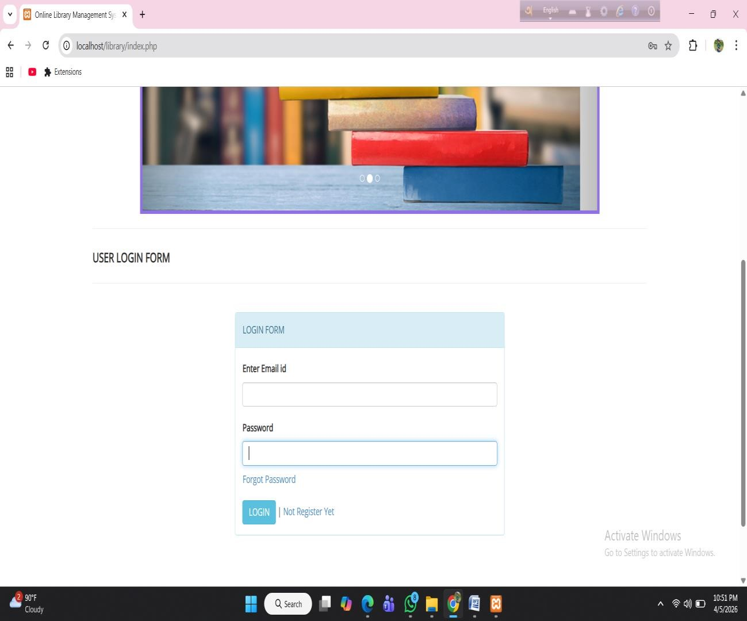
Picture:User Login

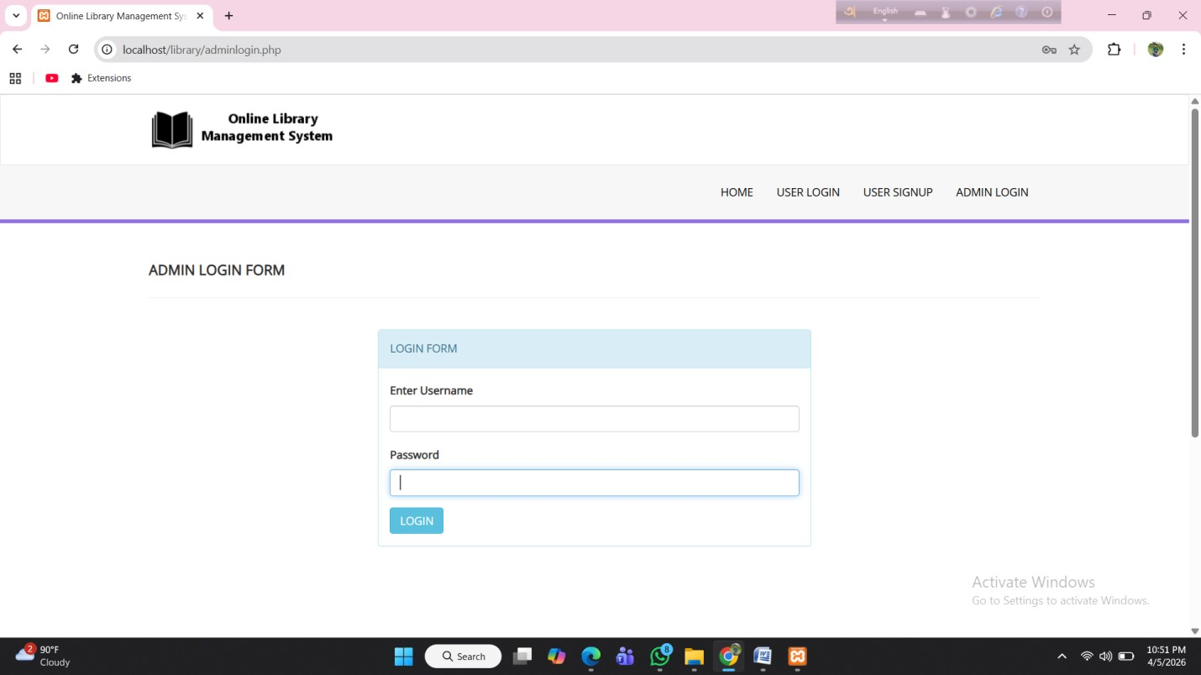
Picture:Admin Login
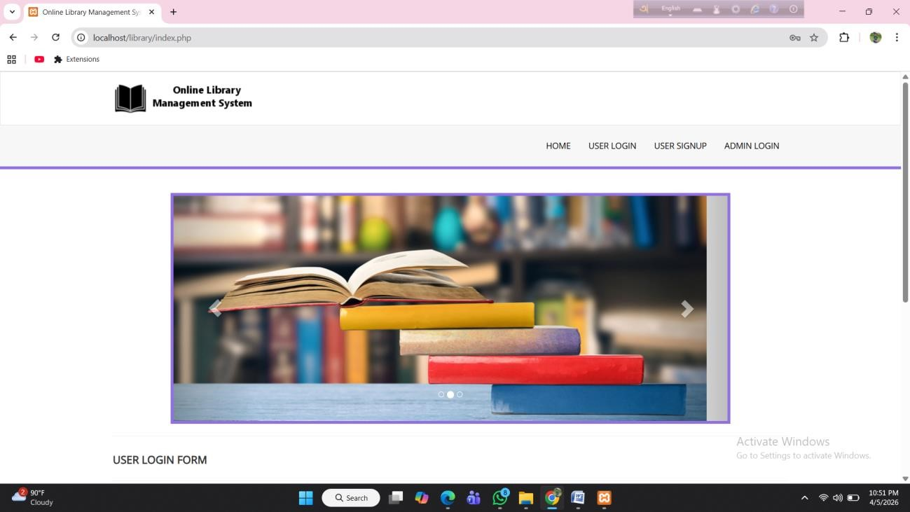
Picture:Homepage

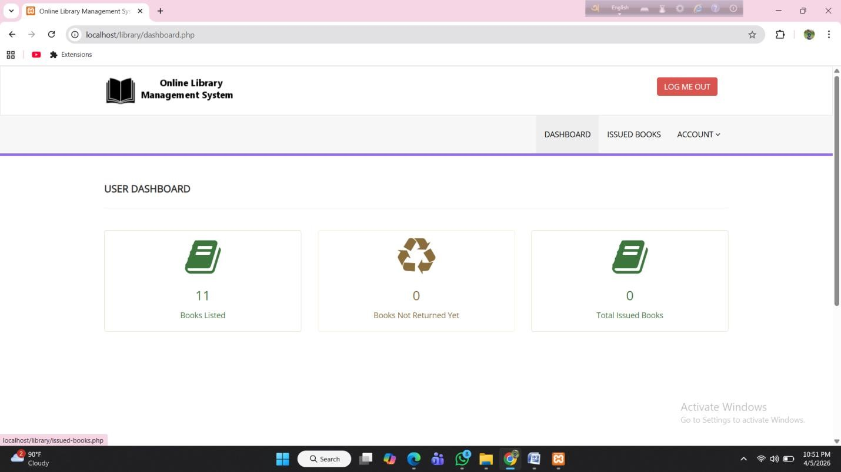
Picture:Dashboard
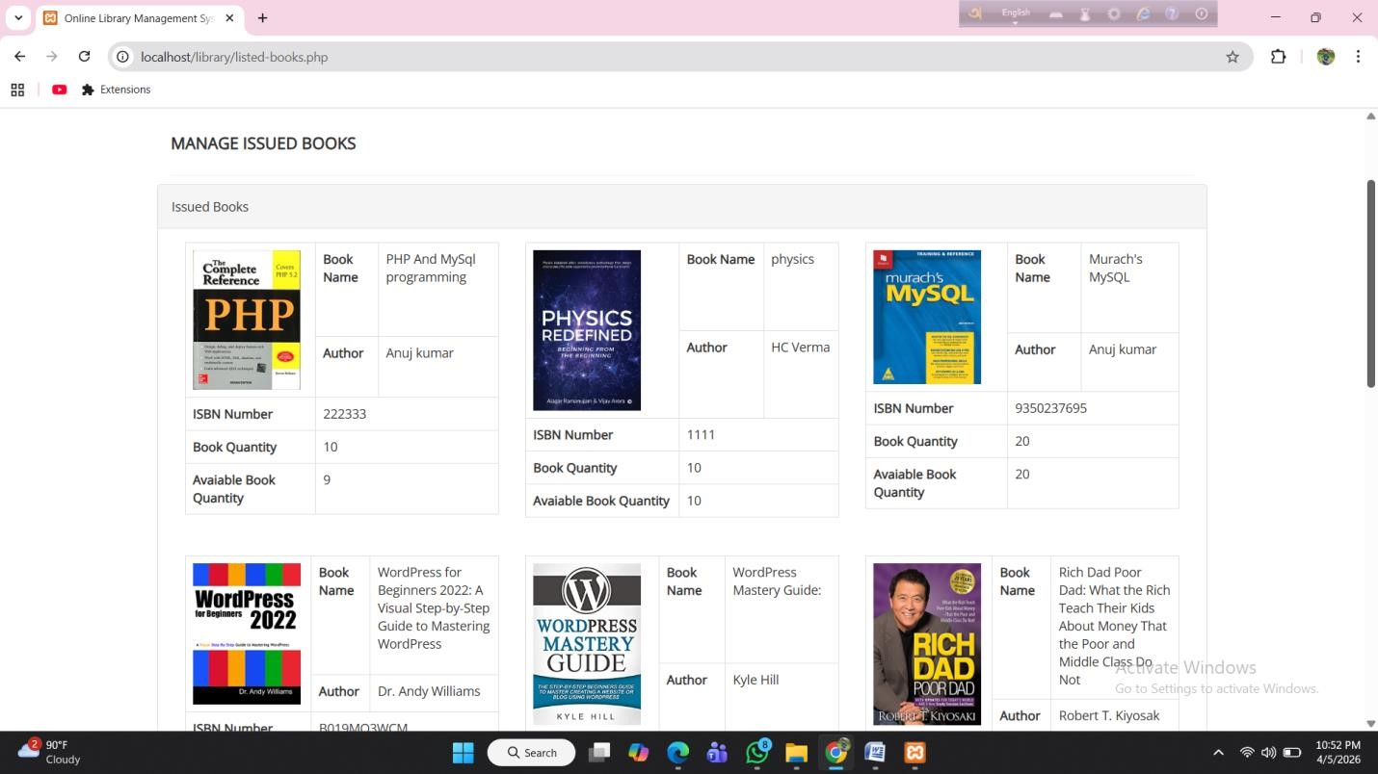
Picture:Issued Book
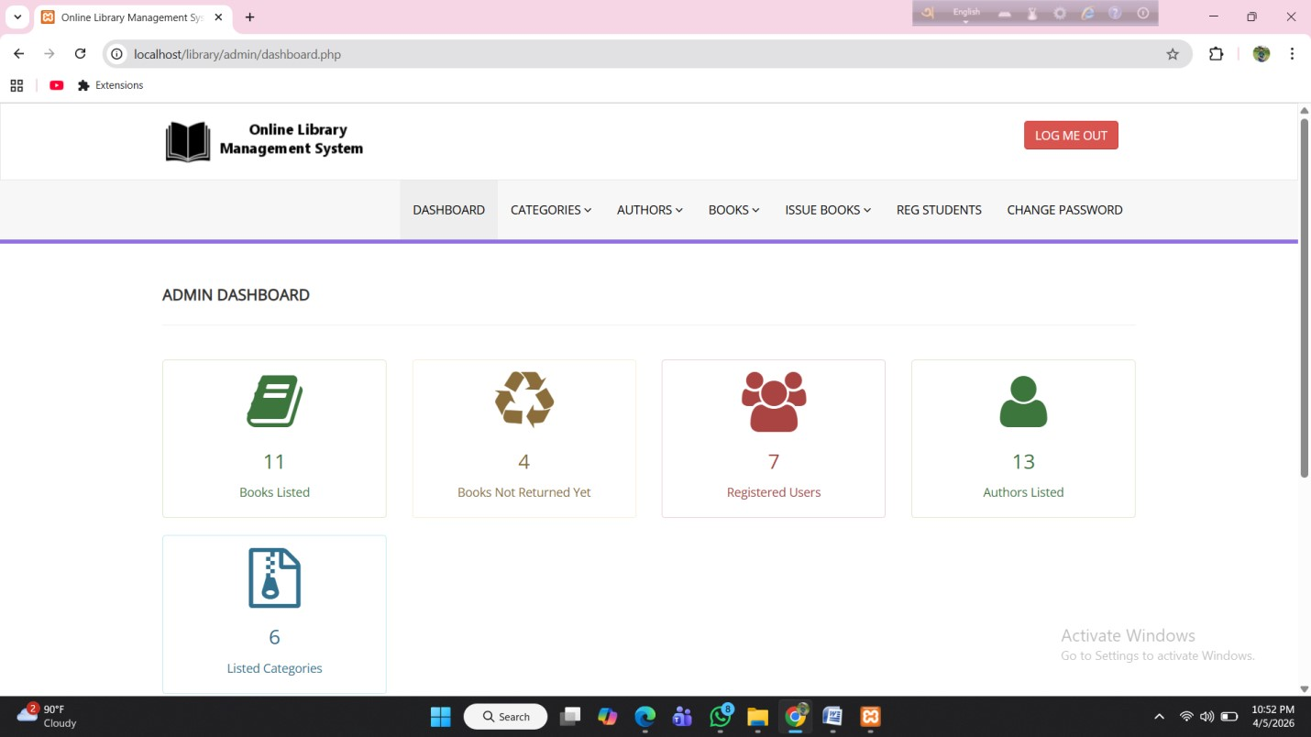
Picture: Admin Dashboard
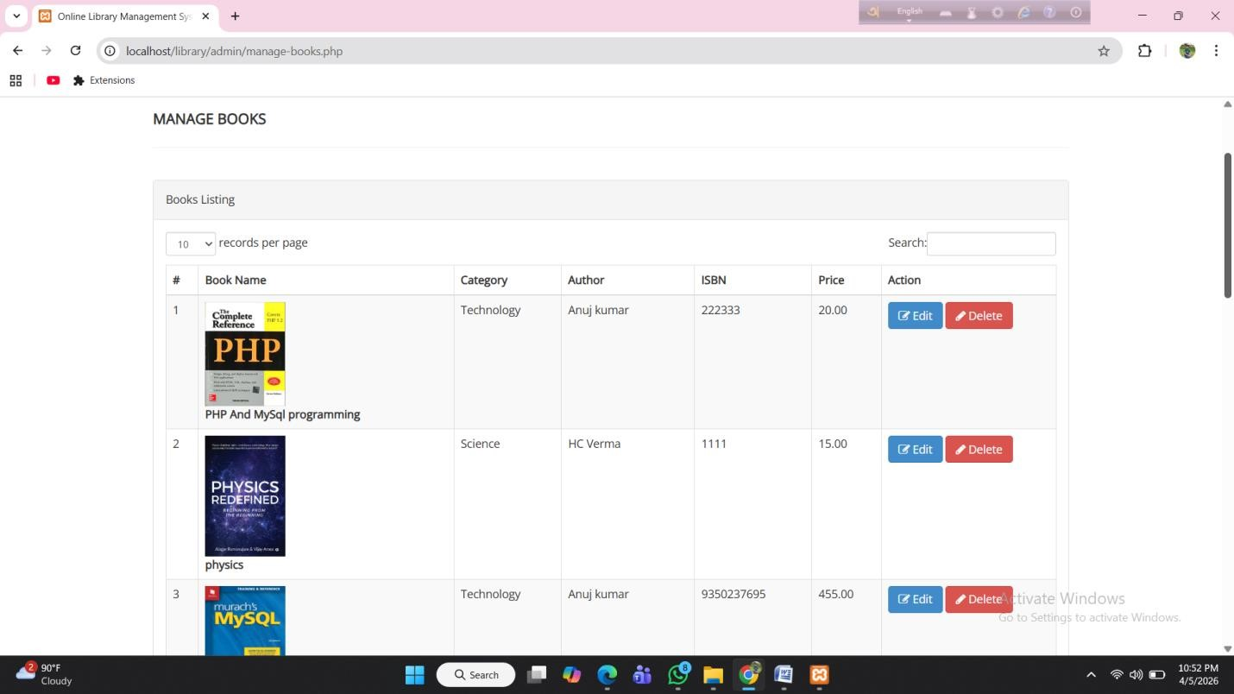
Picture:Manage Books

Chapter 6: Discussion and Future Scopes

6.1 Discussion
The Library Management System was developed to provide a convenient and efficient platform for managing library operations digitally. The system eliminates the need for manual record-keeping and allows users to search, borrow, and return books easily from anywhere within the system.
The application integrates frontend and backend technologies to create a complete management solution. It includes major functionalities such as user registration and login, book searching and browsing, borrowing and returning management, and admin control. The system ensures proper data storage, secure authentication, and smooth communication between client and server.
Overall, the project successfully demonstrates how modern web technologies can be used to develop a fully functional library management platform.

6.1.1 Achievements
- User-Friendly Interface:
The system provides a simple and interactive interface for users to easily search, borrow, and return books.
- Efficient Book Management:
Admin can add, update, and delete book records, ensuring proper management of library resources.
- Secure Authentication System:
Users must register and log in before accessing system features, ensuring account security.
- Borrow/Return Management:
Users can borrow books, return them, and the system keeps track of issue and due dates efficiently.
- Transaction Management:
The system stores borrowing records and allows proper tracking of user activities.
- Database Integration:
MongoDB is used to store user data, book information, and transaction records securely.

6.2 Future Scopes
The system can be further enhanced with the following improvements:
Online Reservation System
Allow users to reserve books in advance.
Notify users when reserved books become available.
Advanced Search and Filtering
Add search filters based on author, category, publication year, and availability. Implement sorting by popularity and newest additions.
Borrowing History and Tracking
Enable users to view their borrowing history.
Provide due date reminders and return notifications.
Mobile Application Development
Develop Android and iOS mobile applications.
Add push notifications for due dates and new book arrivals.
AI-Based Recommendations
Suggest books based on previous borrowing history. Provide personalized recommendations to users.
Enhanced Security
Implement Two-Factor Authentication (2FA).
Strengthen data encryption and secure API handling

References
- MongoDB, Inc. (2024). MongoDB Documentation. Retrieved from: https://www.mongodb.com/docs/
- OpenJS Foundation. (2024). Node.js Documentation. Retrieved from: https://nodejs.org/en/docs/
- Express.js. (2024). Express.js Official Documentation. Retrieved from: https://expressjs.com/
- Meta Platforms, Inc. (2024). React.js Documentation. Retrieved from: https://react.dev/
- Axios Contributors. (2024). Axios HTTP Client Documentation. Retrieved from: https://axios-http.com/
- Postman, Inc. (2024). Postman API Platform Documentation. Retrieved from: https://learning.postman.com/
- Silberschatz, A., Korth, H. F., & Sudarshan, S. (2021). Database System Concepts (7th ed.). McGraw-Hill Education.
- W3Schools. (2024). HTML, CSS, JavaScript Tutorials. Retrieved from: https://www.w3schools.com/
- Mozilla Developer Network (MDN). (2024). Web Development Documentation. Retrieved from:
https://developer.mozilla.org/
- Fielding, R. T. (2000). Architectural Styles and the Design of Network-based Software Architectures (Doctoral dissertation, University of California, Irvine).

